**ASSIGNMENT # 2**

**Remote Patient Monitoring System**

**NAME:** Alap Gohar

**CMS:** 502082

**SECTION:** AI-1A

**Console Based Testing Screenshots**

1. **Adding Patients**
2. **Scheduling Appointments**
3. **Doctor Feedback**
4. **Processing Vitals**

**SOLUTION:**

All the cases are tested in the following Main program:

// required imports

import UserManagement.Patient;

import UserManagement.Doctor;

import AppointmentScheduling.Appointment;

import AppointmentScheduling.AppointmentManager;

import DoctorPatientInteraction.Feedback;

import DoctorPatientInteraction.Prescription;

import HealthDataHandling.VitalSign;

import java.sql.Date;

import java.util.ArrayList;

public class Main {

    public static void main(String[] args) {

        // Creating a Patient

        Patient patient1 = new Patient("P001", "John Doe", "johndoe@example.com");

        System.out.println("Patient Created: " + patient1);

        // Creating a Doctor

        Doctor doctor1 = new Doctor("D001", "Dr. Smith", "drsmith@example.com");

        System.out.println("Doctor Created: " + doctor1);

        Date currentDate = new Date(System.currentTimeMillis());

        // Adding a Vital Sign

        VitalSign vital1 = new VitalSign("P1001", 72.5, 98.6, 120.0, 98.0, currentDate);

        // adding the vitalsign to database for patient

        patient1.uploadVitalSign(vital1);

        System.out.println("Vital Sign Added: " + vital1);

        // Scheduling an Appointment

        Appointment appointment = new Appointment(currentDate, doctor1, patient1);

        // scheduling the appointment using the appointment manager

        AppointmentManager.requestAppointment(appointment);

        System.out.println("Appointment Scheduled: " + appointment);

        // comments for prescription

        String comments = "Mild Flu";

        // prescription

        ArrayList<Prescription> prescriptions = new ArrayList<Prescription>();

        prescriptions.add(new Prescription("Azomax 250mg", "1+1", "15 days"));

        prescriptions.add(new Prescription("Panadol", "1+1", "5 days"));

        // Doctor Providing Feedback

        Feedback feedback = new Feedback(comments, prescriptions, currentDate);

        System.out.println("Doctor Feedback: " + feedback);

    }

}

**OUTPUT:**

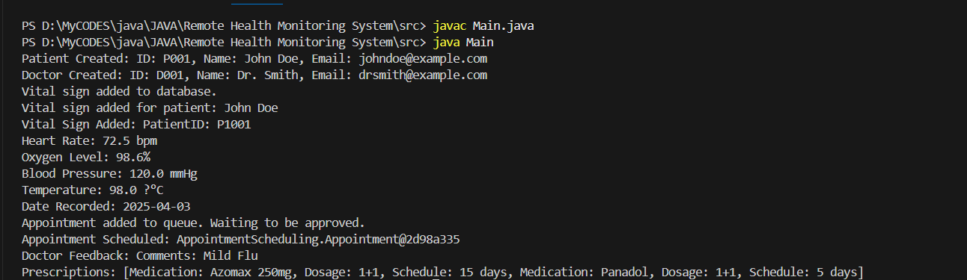

**TESTING EMAIL/SMS ALERT SYSTEM:  
**

**OUTPUT:  
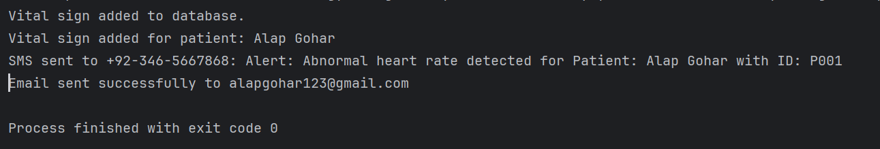**

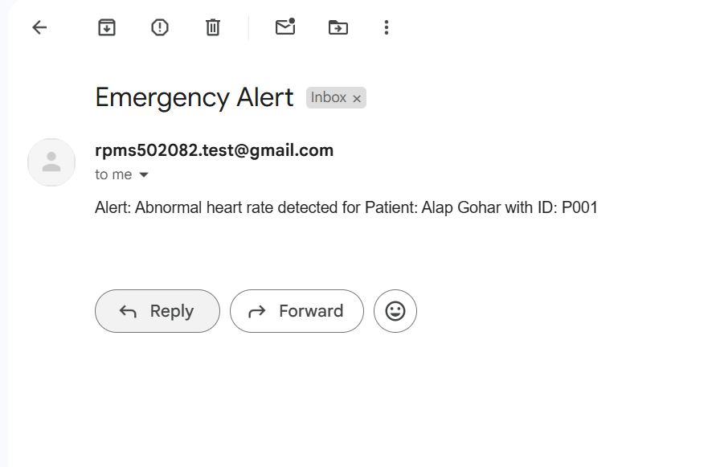

**When new Vital Sign is added with alarming vitals, automatic alert is sent as seen below.**

**Same Implementation for panic button.**



**OUTPUT:**



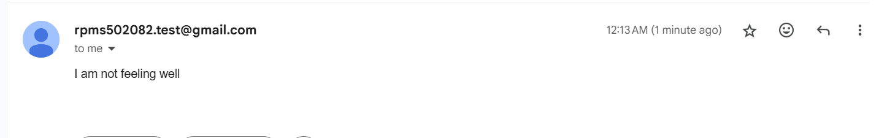

**TESTING THE VIDEO CALL FEATURE:**

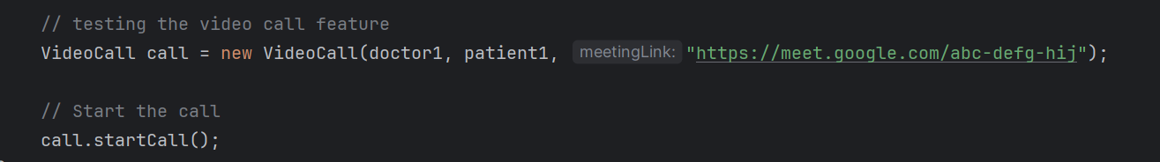

**OUTPUT:  
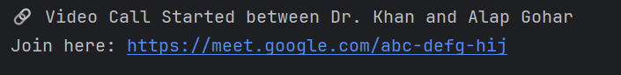**

**GITHUB LINK:**

<https://github.com/alapg09/RemotePatientMonitoringSystem>